Task 2 {devops}

Made by: Hamza Ayman

1. *What is Devops:*

The combination of cultural philosophies, practices, and tools known as DevOps improves an organization's capacity to deliver applications and services at high velocity: products evolve and improve more quickly than they would in organizations using conventional software development and infrastructure management processes. Organizations may provide better customer service and compete more successfully in the market because of this speed.



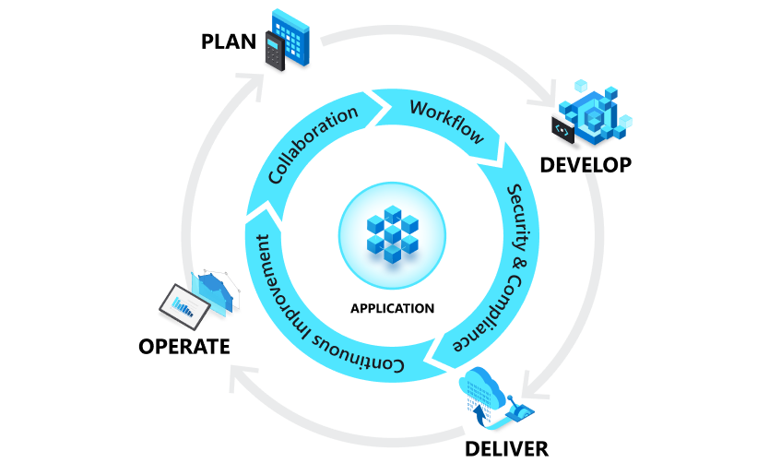

1. *How it works:*

Development and operations teams are no longer "siloed" under a DevOps approach. There are instances when these two teams are combined into one, where the engineers work across the whole application lifecycle—from development and test to deployment and operations—and acquire a variety of skills that are not specific to any one function.

Quality assurance and security teams may also interact more closely with development and operations throughout the lifecycle of an application under various DevOps models. DevSecOps is a term used to describe a DevOps team where security is everyone's top priority.

These teams employ procedures to automate slow and manual tasks from the past. They employ a technological stack and tooling that facilitate the speedy and dependable operation and evolution of applications. The use of these tools also enables engineers to autonomously complete tasks (such as provisioning infrastructure or delivering code) that previously required assistance from other teams, which further boosts a team's velocity.

1. *Why we use Devops*:

The world and its sectors, from retail to entertainment to finance, have been completely altered by software and the Internet. Software now plays a crucial role in every aspect of a business, going beyond simply helping. Through software supplied as online services or applications and on a variety of devices, businesses communicate with their customers. Additionally, they employ software to transform every step of the value chain, including logistics, communications, and operations, in order to improve operational efficiencies. Companies now must change how they produce and distribute software in a similar way to how physical goods companies changed how they design, build, and deliver things utilizing industrial automation throughout the 20th century.

1. *When do we use Devops:*

In order to increase the flexibility of their systems and promote rapid innovation, organizations may also employ a microservices design. Large, complicated systems are decoupled into small, independent projects using the microservices design. Applications are divided into numerous separate parts, or "services," each of which is focused on a particular objective or set of operations and is run independently of the application as a whole and its peer services. With this design, updating apps requires less coordination, and businesses may move more quickly when each service is coupled with a small, agile team that is responsible for it.

Microservices and more frequent releases result in much more deployments, nevertheless, which can provide operational difficulties. As a result, DevOps techniques like continuous integration and delivery let enterprises produce quickly while being secure and dependable. Practices for infrastructure automation, such as infrastructure as code and configuration management, aid in maintaining the elasticity and responsiveness of computing resources to frequent changes. Engineers can watch the performance of applications and infrastructure with the use of monitoring and logging, which enables them to respond promptly to issues.